**Part 1: Setting Up LAMP Stack:**

1. Instance Launched

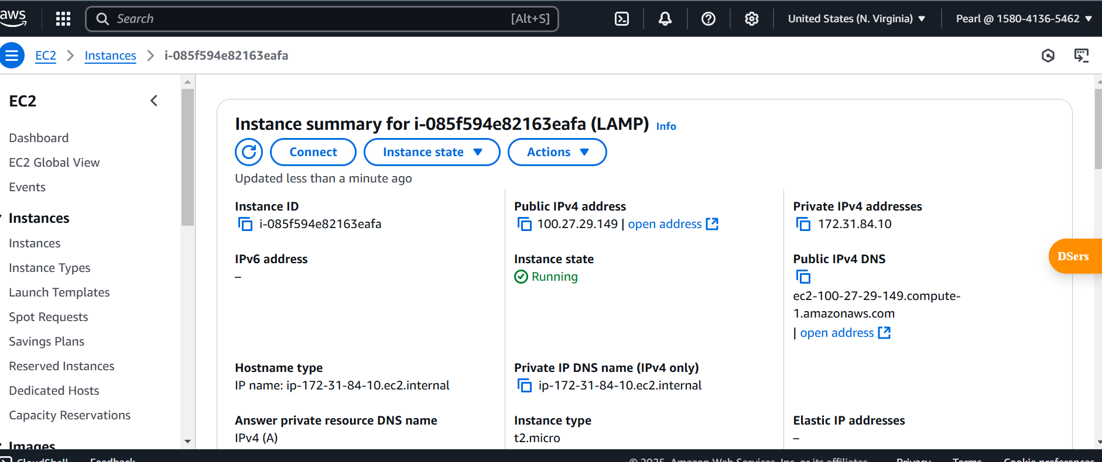

1. Sudo Apache Update - Upgrade Screenshot

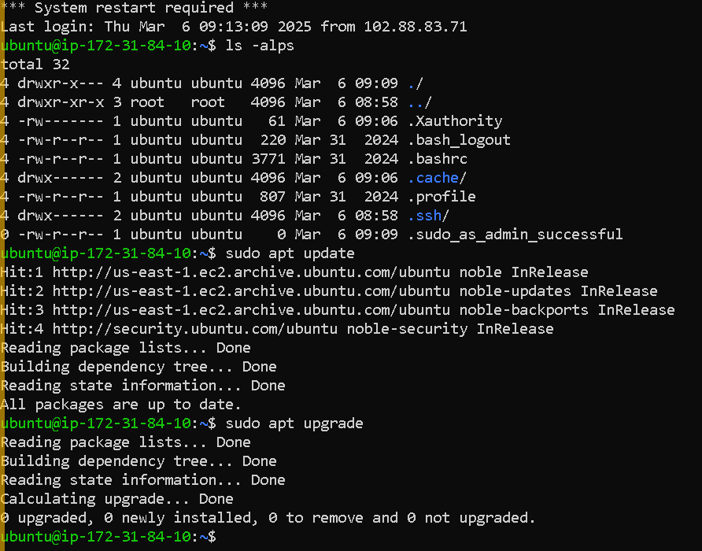

1. Sudo Apache - Install

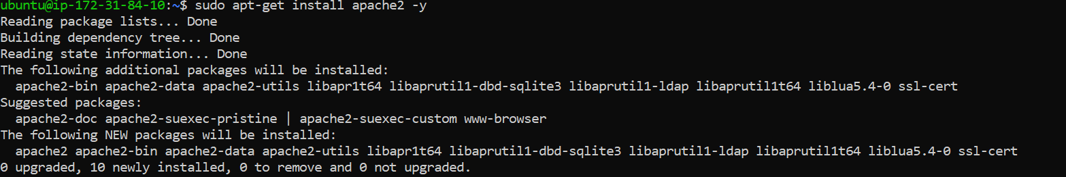

1. Apache Start, Enable & Status

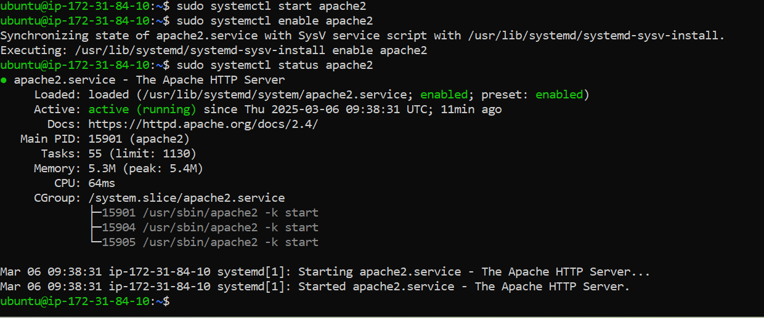

1. Apache server is up!

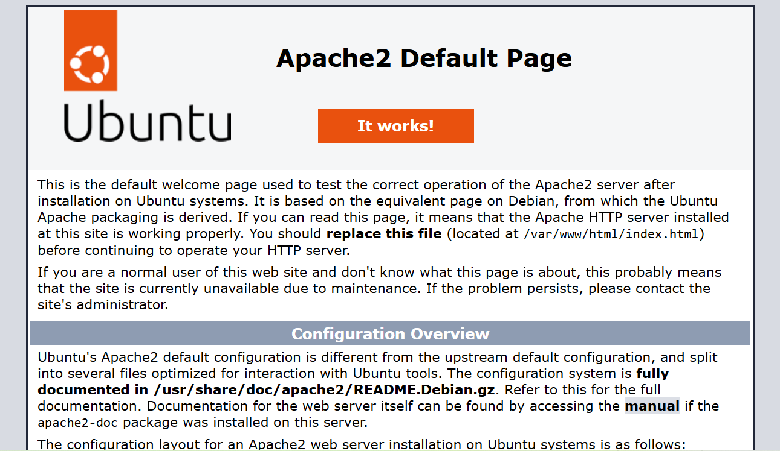

1. Mysql-Install Command

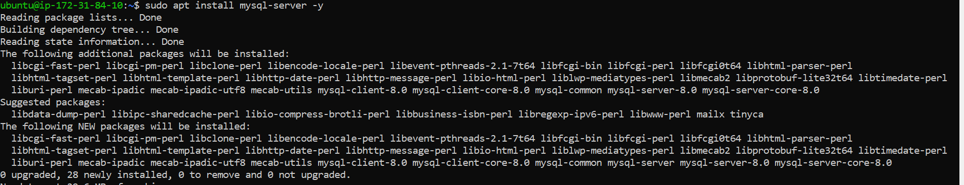

1. Mysql Enable-Start-Status

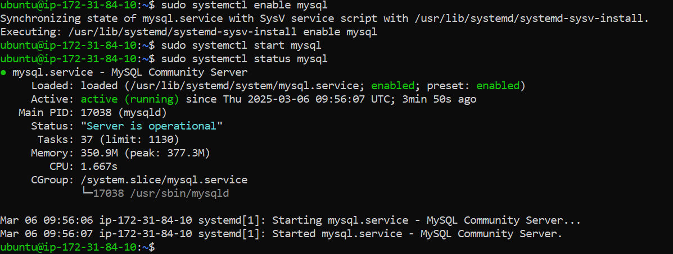

1. PHP Install-Command

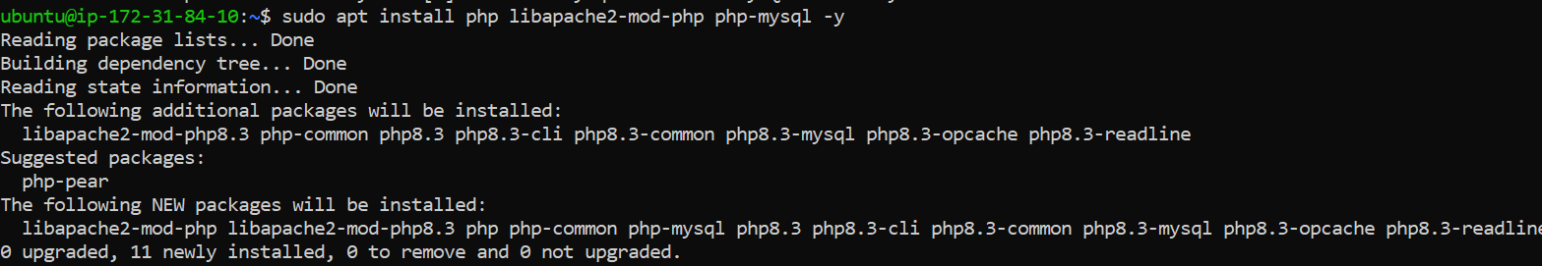

1. Confirmed PHP is Installed

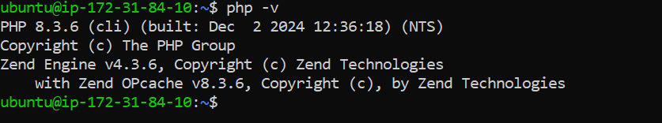

1. Config Apache to use PHP



1. Created Info.phpfile-intohtml

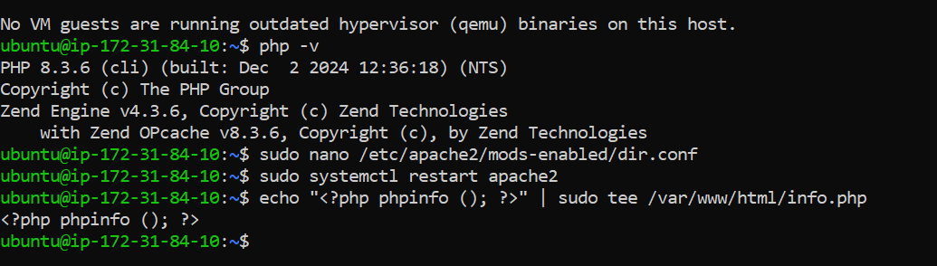

1. PHP Apache Server is up!

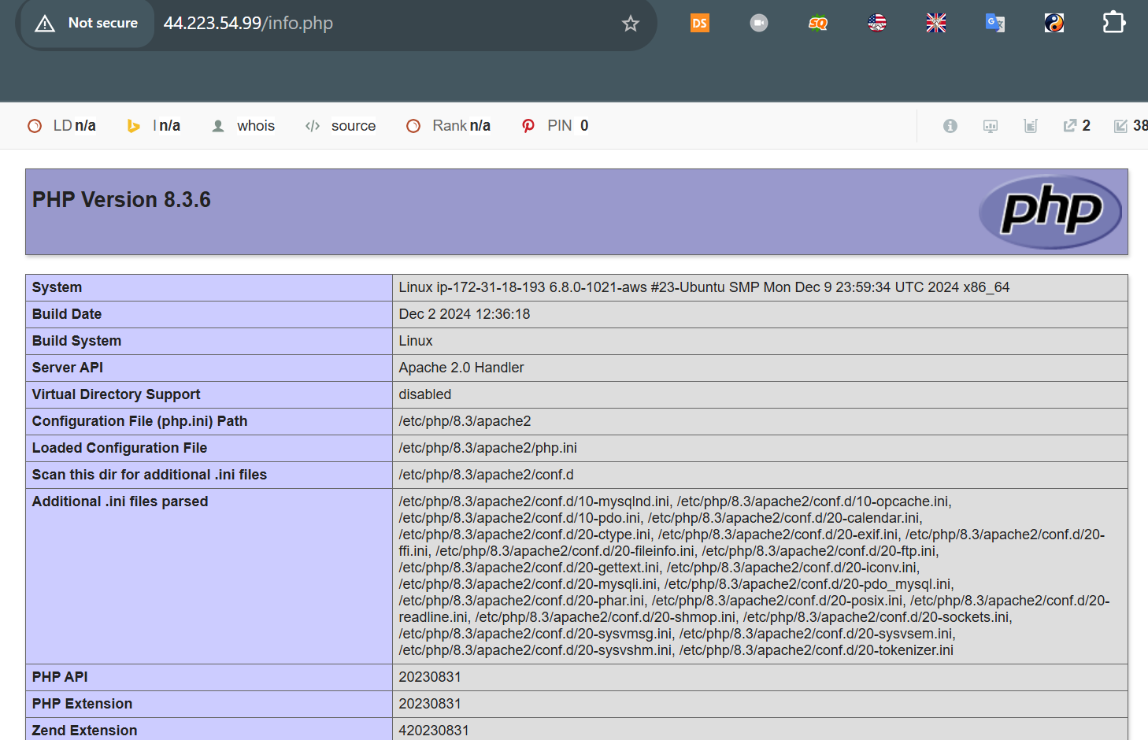

**Part 2: Setting Up LEMP Stack:**

1. LEMP Instance-Details

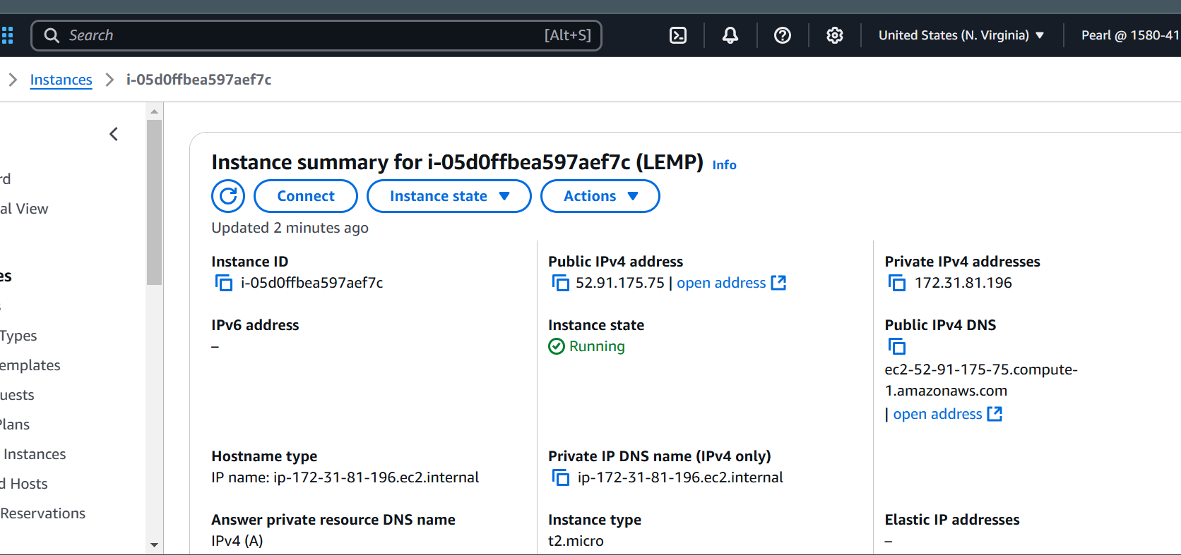

1. Updated & Upgraded Installed Packages



1. Nginx Install - Command



1. Nginx Enable - Start

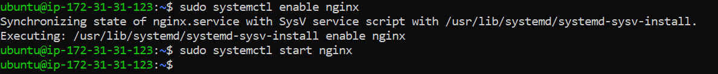

1. Mysql Install-Command  
   
2. Mysql - Status

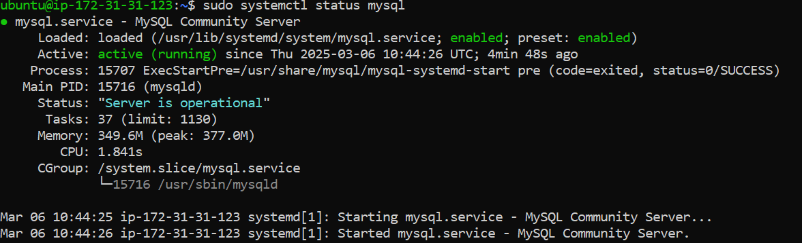

1. NGINX Server-up

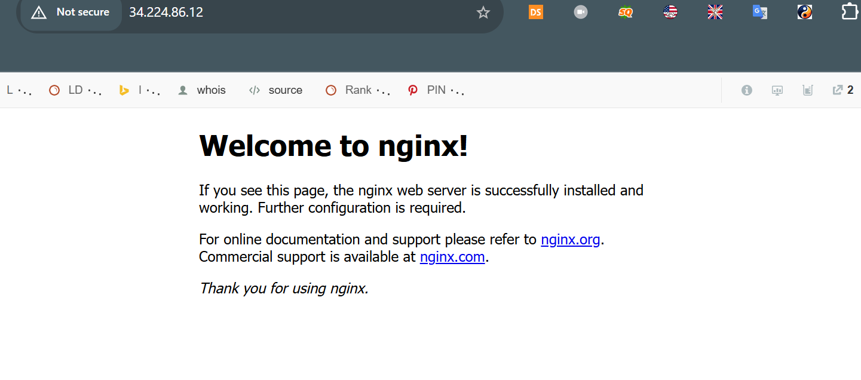

1. PHP Install - Command

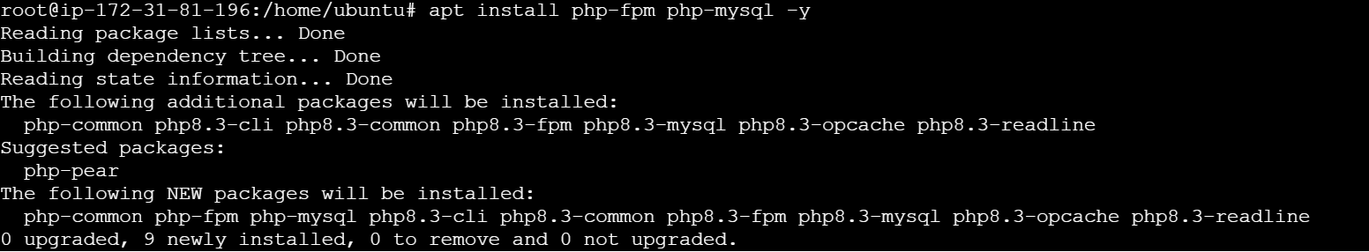

1. PHP Status-Check

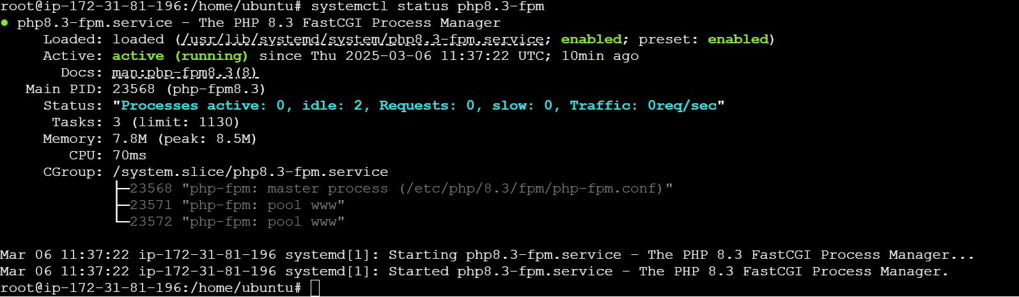

1. PHP Version - Check

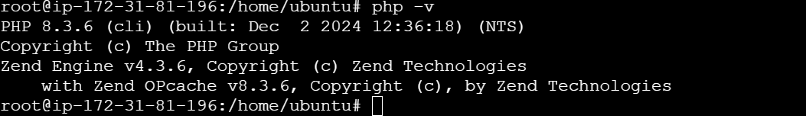

11. NGINX PHP - Server is up!

